AWS PROJECT 2

DEPLOY APPLICATION ON CLOUD

AIM: The aim of this project is to create and deploy ROS (Robot Operating System) on Cloud for IS Robotic software and to allow the developers to run their robotic simulation and do more implementation.

Requirements for the Cloud

Ubuntu 20.04 LTS

General purpose t2.micro.

30GB of Storage

Prerequisites Create a AWS Account

CREATED VPC PUBLIC ACCESS LAUNCH EC2 INSTANCE SELECTED UBUNTU 24
T2 MICRO
ADDED SSH RULE IN SECURITY GROUP ,HTTP,HTTPS CONNECT EC2 INSTANCE

USED ROC WEBSITE TO INSTALL APPLICATION USED ROCVERSION -D
PFB SNAP

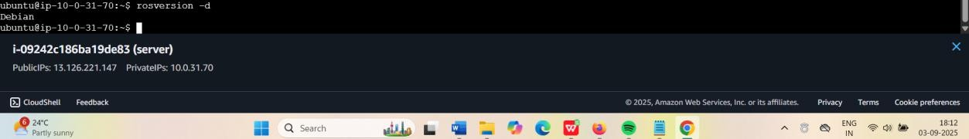

- Setup your sources.list
sudo sh -c 'echo "deb http://packages.ros.org/ros/ubuntu $(lsb_release -sc) main" > / etc/apt/sources.list.d/ros-latest.list'

- Set up your keys

sudo apt install curl # if you haven't already installed curl curl -s https://raw.githubusercontent.com/ros/rosdistro/master/ros.asc | sudo apt-key add

- Installation And updation of ROS
sudo apt update

sudo apt install ros-noetic-desktop-full

- Environment setup

source /opt/ros/noetic/setup.bash

